**Project Description of Group 4**

**Topic: Clinical Management System**

**Taha Mohamed Alzain(2669055)**

**Muhammad Nadeem 266704**

**Fadi Atia Dasus(266265)**

**Oskars Arajs(266534)**

**Alexandru Vieru(267013)**

4

**Supervisors**

Ole Ilsgaard Hougaard

Mona Wendel Andersen

Jens Cramer Alkjærsig

Martin Zmija

**ICT Engineering, VIA University College, Horsens**

**2nd Semester (08-03-2018)**

**Table of content**

1 Background Description and Purpose 3

2 Definition of purpose 4

2.1 Problem Statement 4

2.2 Delimitation 4

3 Choice of Models and Methods 5

4 Time Schedule 6

5 Risk assessment 7

6 References 8

# 

# 

# 

# 

# 

# 

# 1 Background Description and Purpose

FONT is a clinic devoted to diagnostic medicine. Up till now FONT used an outdated system (pen and paper), which needed a lot of storage space and took considerable amount of time to perform actions like writing medical history and updating existing ones. Writing everything by hand is bad practice because not everyone can read that handwriting and that could cause misinformation and, worst case scenario, a person’s death since his medical history was misread.

Safety of documents is imperative. The documents need to be stored somewhere in the immediate vicinity so that only approved staff can have access to it. That means that the clinic needs a storage space to store all relevant patient documents and the storage space needs to be waterproof/fireproof so that the elements do not damage the documents because. Time has a significant impact on the quality of the documents, every day that the documents stay in the storage space increases the deterioration of the documents and that leads to information being lost or unreadable. And keeping multiple copies in the same storage space is likely to lead to both copies being lost in an accident.

Booking an appointment might turn out to be a struggle for the nurse. Doing the booking procedure in handwriting takes a lot of time for each person coming in the clinic. There is some time needed to book a person for an examination and If there are a lot of people coming in then for the last person it will take much more time to be booked. This problem could be nullified by creating a web-based system that has worked for different clinics, where patient can login to amend personal information and book appointment their self. But regarding to the FONT clinic, it is not feasible due to most elderly patients should have problem with online system and payments.

In addition, the medical personnel agree that the clinic needs a system which can save valuable time for the clinic's daily activities.

This would ease access to all patient documents and make creating them and booking examinations more pleasant and easier.

# 2 Definition of purpose

The purpose of this project is to create a system that could handle the clinic’s daily activities and improve time consumption.

## 2.1 Problem Statement

The project focus will be on how the system will handle several users at the same time, and how the system will keep all the users updated with the latest version of the information that would be stored and retrieved.

Thinking about that, states several challenges for the team. Such as the following questions:

1. How to make an efficient system that meets the clinics necessities.

2. How to specify the roles for each user in the system, in a way that gives each client access to only a specific part of the application.

3. How to model the data that will serve the Clinic's needs.

4. How to manage the process of renewing the patient’s medicine.

## 2.2 Delimitation

1. web based system development
2. Patients are not allowed to pay bills
3. The system must allow the secretary to be able to send a request to get the medicine renewed by the doctor.
4. The system must allow the doctor to be able to add a patient’s medical case.
5. The system must allow the doctor to be able to add a medical prescription to the patient’s medical record.
6. The system must allow the doctor to be able to renew medicine prescription for the patient.
7. The system must allow the doctor to be able to approve the requested medicine that comes from the secretary.
8. The system must allow the doctor to be able to add new medicine information.
9. The system must allow the doctor to be able to remove medicine.
10. The system must allow the doctor to be able to edit existing medicine.
11. The system must allow the doctor to be able to search for medicine.
12. The system must allow the secretary to be able to edit an appointment

# 3 Choice of Models and Methods

|  |  |  |  |
| --- | --- | --- | --- |
| **What partial problem.** | **Why this problem.** | **Which methods/ models/ theories will be used?** | **Who in the group is the main responsible person for this point?** |
| How to make an efficient system that meets the clinics necessities. | If there is no viable system, then the clinics main necessities will not be fulfilled. | MVC |  |
| How to manage the process of renewing the patient’s medicine. | for time saving |  |  |
| How to specify the roles for each user in the system, in a way that gives each client access to only a specific part of the application serves the Clinic's needs | without dividing the rules between the clinics staff members, leading to have access level for all users. |  |  |
| How to model the data that will serve the Clinic's needs. | Poor modeling choices lead to an inefficient system. |  |  |

# 4 Time Schedule

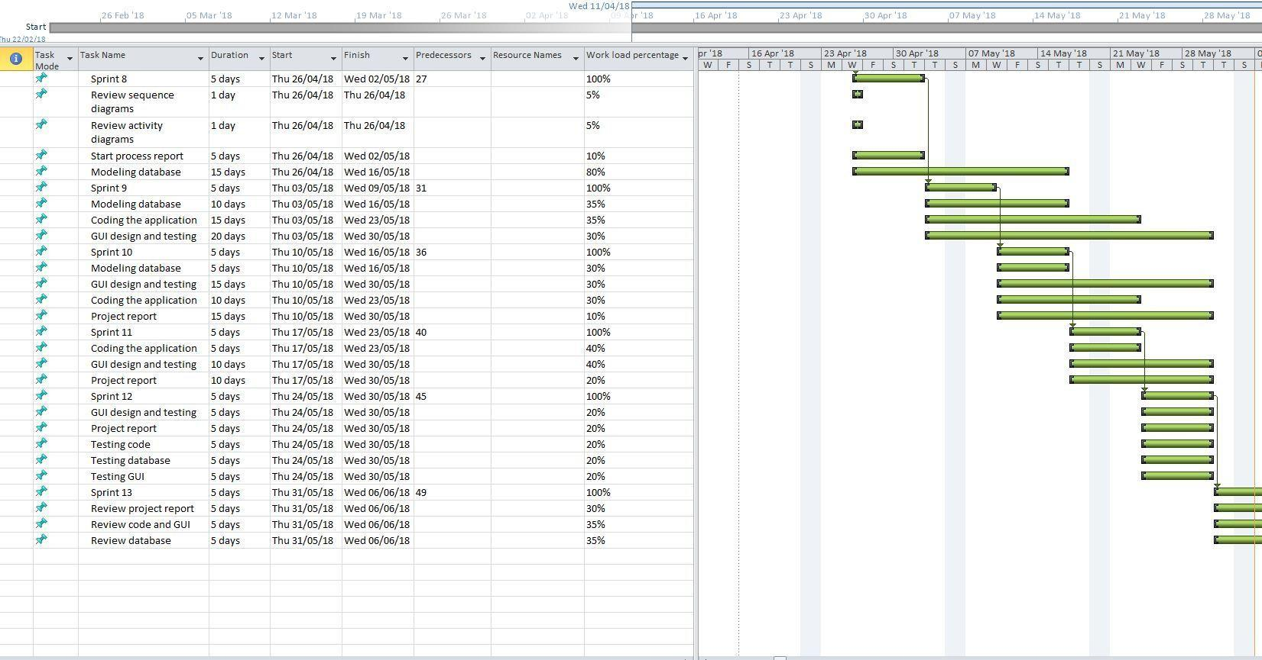

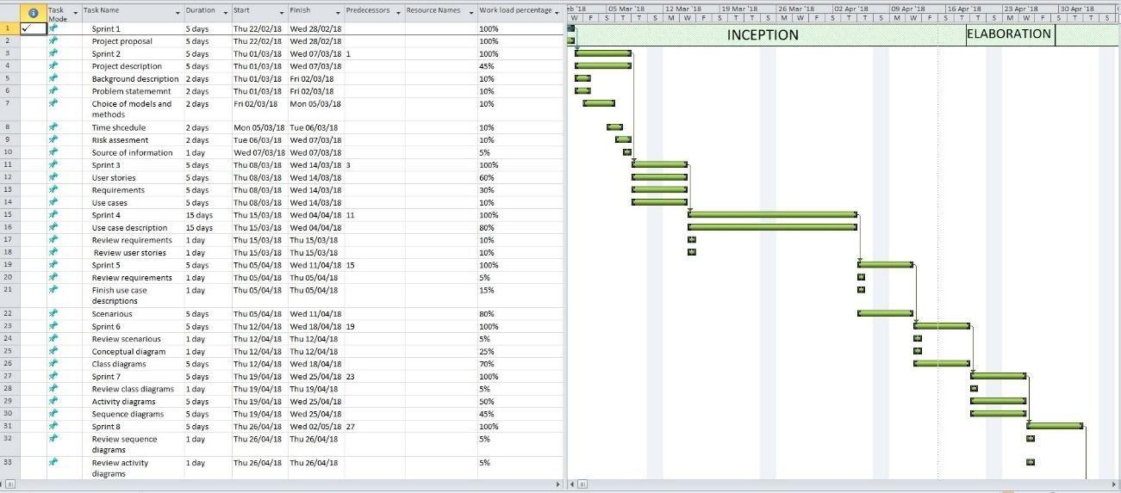

# 5 Risk assessment

|  |  |  |  |  |
| --- | --- | --- | --- | --- |
| Risk | Description | Severity (scale 1-5) | Risk Mitigation,  e.g.​ ​Preventive &​ ​Responsive Actions | Responsible |
| Data corruption | a mistake causing loss in data | 3 | GitHub,​ ​Slack, Google​ ​Docs | All members |
| lack of knowledge | Inability to implement functions based on design | 4 | supervisors,  external resources from the internet | All members |
| missing group meeting | group members prevent to come to the meeting for any reasons | 1 | good communication | All members |
| missing a group member | An​ ​accident causing​ ​a member​ ​to be​ ​unable​ ​to work | 1 | none | God |
|  |  |  |  |  |

# 6 References

Project description, 2017 (Appendix 1) VIA Engineering Guidelines [Last accessed 27/02/2018] via link:<https://studienet.via.dk/projects/Engineering__project_methodology/General/Guidelines/2017%20Project%20Description%20(Appendix%201)%20-%20VIA%20Engineering%20Guidelines.pdf>